Procedure:
- Start heating water in a beaker on a hot plate.
- Place three Styrofoam cups upside down on a piece of paper, making a triangular shape.
- Place clear plastic pan on top of the Styrofoam cups. The cups should be near the outside edge of the pan.
- Fill the plastic pan ¾ full with cool water. Let the water still and DO NOT bump the pan during the experiment.
- Slowly release a small amount of food coloring in the middle of the plastic pan at the bottom and slowly remove the dropper from the plastic pan.
Describe, in detail, what is happening to the food coloring placed in the water.

- Empty the plastic pan of water and refill with cool water. The pan should be set back on top of the cups.
- Carefully pour the very hot water from the beaker into a Styrofoam cup while wearing gloves. Slide the hot Styrofoam cup to the middle of the plastic pan. Let the water in the pan still.
- Repeat step 5. Observe the food coloring over several minutes.

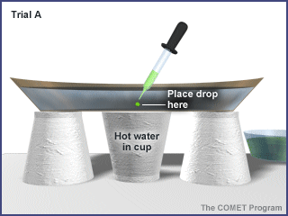
Make observations to what is happening to the food coloring in the plastic pan. Draw a picture of what is happening using a topview and a side view of the plastic pan.

- Repeat steps 6 – 8two times more placing the drop of food coloring in the places designated by the pictures.

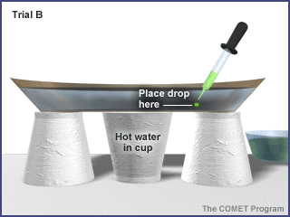
Observe the food coloring in the pan and write down what you see. Again draw a picture for both the top view and the side view.

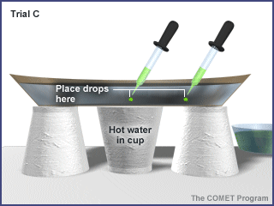
In this last trial, write down your observations of the food coloring. Draw a picture of the top view and the side view.

Conclusion and Analysis
- Which energy or heat transfer is being shown in this experiment? Describe the type of heat transfer shown in 2-3 sentences.

- What does the movement of the food coloring in the water represent?

- What effect does the hot water in the center under the plastic pan have upon the currents?

- For each trial, where in the plastic pan was the food coloring flowing upward? Where was the food coloring flowing downward?

- What do you think would happen if the water in the plastic pan and the cup were reversed: hot water in the pan and the cold water in the Styrofoam cup?

- Using this experiment as a guide, describe how this heating process works while a pot of water heats up on a stove.

